Big Mountain Resort Report

My current client is Big Mountain Resort, a ski resort located in the heart of Montana. Offering an array of views from the slopes such as Glacier National Park and Flathead National Forest. Offering an abundance of amenities, Big Mountain Resort gets the honor to host 350,000 visitors per ski season. With a rise in resort attendance, Big Mountain Resort invested in a new chair lift to expedite the wait time to back up the mountain. The new chair lift is coming with its downside as it has added the burden of an extra $1,540,000 in maintenance costs. I have been hired to review options to cut costs down or if I need to raise ticket prices. 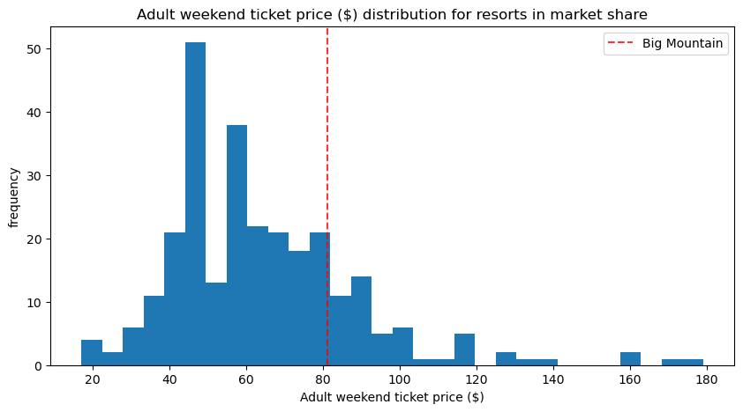

In the first image above you will see that we currently stand at $81 per ticket, which in comparison to the region is right around above average. This is a deal considering we have some of the most amenities in the region. Big Mountain Resort is one of the leaders in the skiable terrain, length of course, amount of runs, chair lifts, and vertical drop as well. Below you will see we are already the most expensive Resort in the state of Montana. Supporting a slight ticket increase would not change anything.

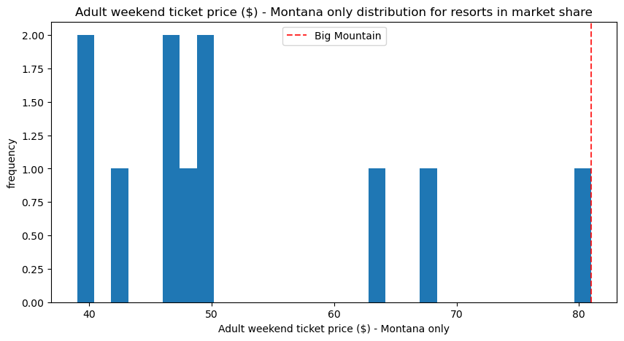

Also below you will see closing runs at this point to reduce maintenance cost is not an option. Big Mountain Resort already has an extra expenditure in maintenance cost and reducing revenue would result in the same problem we are in. Closing 1 run would not change revenue, but removing more than one run would result in revenue loss.

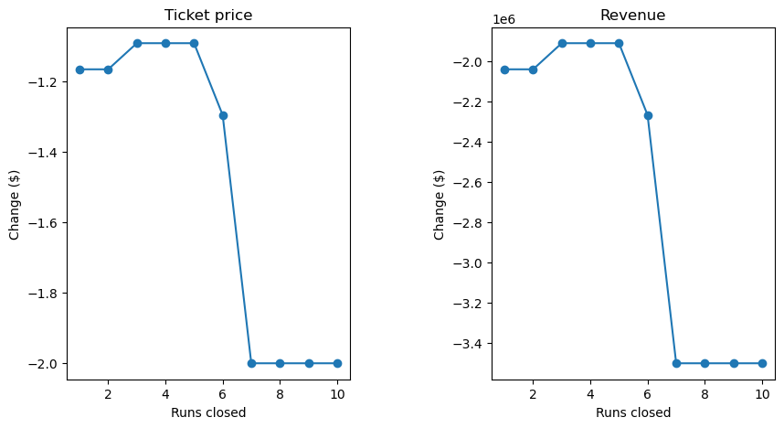

Using the prediction model, there are two options we can add to Big Mountain Resort to have the reason to increase the ticket price. Models show that adding just another chair lift and 150ft in vertical drop, we can increase our ticket price to $82.31. That is just a 1.7% increase in ticket price, which comes with an additional $2,300,926 in revenue. That would give us surplus after the additional maintenance cost.

Our other model shows that for the same price increasing if we increase snow making by 2 acres. Either of these I would support.

After concluding the date I would recommend we increase snowmaking to an extra 2 acres. Along with that I recommend we raise the ticket price from $81 to $82.31. We are one of the leaders in chair lifts and vertical drops already. Adding to snow making will bolster our amenities and justify our slight ticket increase. Already being the leader in ticket price for the state, I do not see a ticket price increase affecting our customer base. Adding to our amenities will also justify us having a higher ticket price than others. A price increase of $1.31 and a 2 acre snow making increase. is what I recommend Big Mount Resort does.